

Requirement & Design Specification

**Badminton Court Booking Platform**

**Version: 2.0**

– HCM, July, 2024 –

# 

# Record of Changes

|  |  |  |  |  |
| --- | --- | --- | --- | --- |
| Version | Date | A* M, D | In charge | Change Description |
| V1.0 | 1/6 | A | Trần Thành Đạt | Added class diagram |
| V1.1 | 4/6 | A | Trương Tấn Huy | Added the use case diagram |
| V1.2 | 9/6 | A | Nguyễn Hà Linh | Added screen flow |
| V1.3 | 14/6 | A | Lê Thành Nhân | Added business rules |
| V1.4 | 16/6 | A | Trương Tấn Huy | Added sequence diagram |
| V1.5 | 18/6 | A | Nguyễn Hà Linh | Added ERD, database |
| V1.6 | 22/6 | M | Lê Thành Nhân | Modified screen flow |
| V1.7 | 26/6 | M | Trần Thành Đạt | Modified use case diagram |
| V1.8 | 28/6 | M | Lê Thành Nhân | Modified business rules |
| V1.9 | 1/7 | M | Nguyễn Hà Linh | Modified sequence diagram |
| V2.0 | 7/7 | M | Trần Thành Đạt | Modified class diagram |
|  |  |  |  |  |

*A - Added M - Modified D - Deleted

Contents

Record of Changes 2

I. Requirements 4

1. User Requirements 4

1.1 Actors 4

1.2 Use Cases 4

2. Overall Functionalities 7

2.1 Screens Flow 7

2.2 Business rules 8

2.3 Requirements 9

III. Design 11

1. Database design 11

2. Class diagram 11

# I. Requirements

## 1. User Requirements

### 1.1 Actors

|  |  |  |
| --- | --- | --- |
| **#** | **Actor** | **Description** |
| 1 | Guest | Users who don’t have an account in the Court Caller system. |
| 2 | Customer | Users who have an account in the Court Caller system and can book the booking services, see their own profile |
| 3 | Staff | Work at branches. Having access to booking for customers and manage customers |
| 4 | Admin | Administrator of the system. |
| 5 | VNpay | 3rd party payment gateway |

### 1.2 Use Cases

#### a. Diagram(s)

#### 

#### b. Descriptions

|  |  |  |  |
| --- | --- | --- | --- |
| **ID** | **Name** | **Actor** | **Description** |
| UC-1 | Register account | Guest | Allows a guest to create an account. |
| UC-2 | Search court information | Guest | Enables a guest to search for court information. |
| UC-3 | Log out | Member | Allows a user to log out of the system. |
| UC-4 | Reset password | Member | Allows a user to reset their forgotten password. |
| UC-5 | Login by system account | Member | Authenticates a user and grants access to the system. |
| UC-6 | Login by Facebook | Customer | Allows a user to login using Facebook credentials. |
| UC-7 | Login by Gmail | Customer | Allows a user to login using Gmail credentials. |
| UC-8 | News | Customer | Allows a customer to view news. |
| UC-9 | Home Page | Customer | Allows a customer to view the home page. |
| UC-10 | By day booking | Customer | Enables a customer to book a court by day type. |
| UC-11 | Flexible booking | Customer | Enables a customer to book a court of flexible type. |
| UC-12 | Fixed booking | Customer | Enables a customer to book a court of fixed type. |
| UC-13 | VN PAY | Customer, Staff | Allows a user to make payments through VN PAY. |
| UC-14 | Payment Detail | Customer, Staff | Allows a user to view payment details. |
| UC-15 | Balance | Customer | Allows a user to view their account balance. |
| UC-16 | View detail | Customer | Allows a customer to view booking details. |
| UC-17 | Cancel | Customer | Allows a customer to cancel a booking. |
| UC-18 | Booking history | Customer | Allows a customer to view their booking history. |
| UC-19 | Check-in for customer | Court Staff | Allows staff to check-in customers. |
| UC-20 | Book Flexible type | Court Staff | Enables a staff to book a court of flexible type. |
| UC-21 | Book Fixed type | Court Staff | Enables a staff to book a court of fixed type. |
| UC-22 | Book By day type | Court Staff | Enables a staff to book a court by day type. |
| UC-23 | Manage account | Admin | Enables an admin to manage user accounts. |
| UC-24 | Edit account | Admin | Allows an admin to edit account information. |
| UC-25 | Add new staff account | Admin | Enables an admin to add new staff accounts. |
| UC-26 | Ban/Unban account | Admin | Enables an admin to ban or unban user accounts. |
| UC-27 | Manage review | Admin | Allows an admin to manage user reviews. |
| UC-28 | Search review | Admin | Enables an admin to search for specific reviews. |
| UC-29 | Delete review | Admin | Allows an admin to delete reviews. |
| UC-30 | Manage payment | Admin | Allows an admin to manage payment details. |
| UC-31 | Search payment | Admin | Enables an admin to search for payment information. |
| UC-32 | View dashboard | Admin | Allows an admin to view the system dashboard. |
| UC-33 | Manage booking | Admin | Enables an admin to manage court bookings. |
| UC-34 | Search booking | Admin | Enables an admin to search for booking information. |
| UC-35 | Delete booking | Admin | Allows an admin to delete bookings. |
| UC-36 | Create court | Admin | Allows an admin to create new court entries. |
| UC-37 | Edit court | Admin | Allows an admin to edit court information. |
| UC-38 | View court | Admin | Allows an admin to view court details. |
| UC-39 | Edit branch | Admin | Allows an admin to edit branch information. |
| UC-40 | Add new branch | Admin | Enables an admin to add new branches. |
| UC-41 | Search branch | Admin | Enables an admin to search for branch information. |
| UC-42 | Manage branch | Admin | Allows an admin to manage branch details. |
| UC-43 | Change slot | Admin | Enables an admin to change booking slots. |
| UC-44 | View time slots | Admin | Allows an admin to view available court time slots. |

## 2. Overall Functionalities

### 2.1 Screens Flow

2.1.1 Guest System

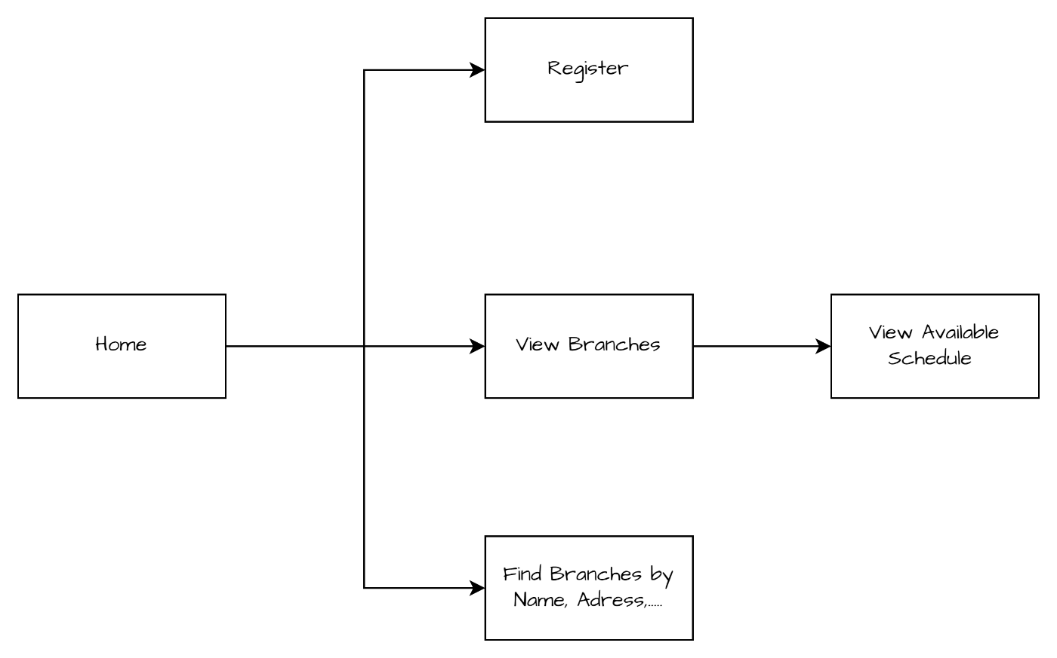

2.1.2 Customer System

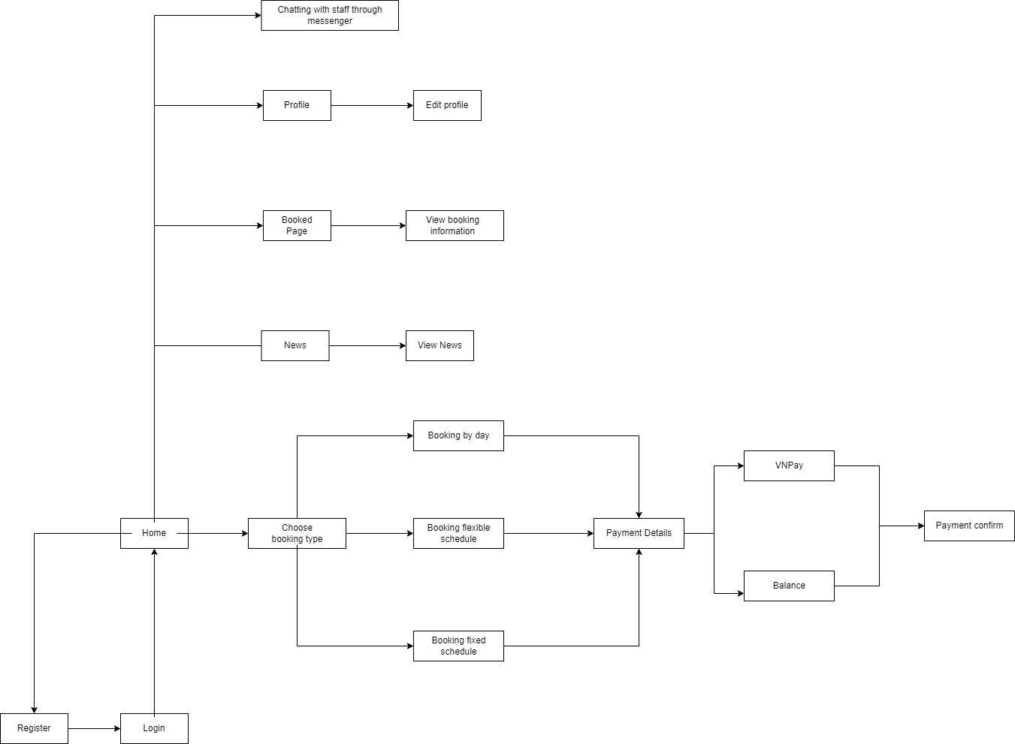

2.1.3 Admin/Staff System

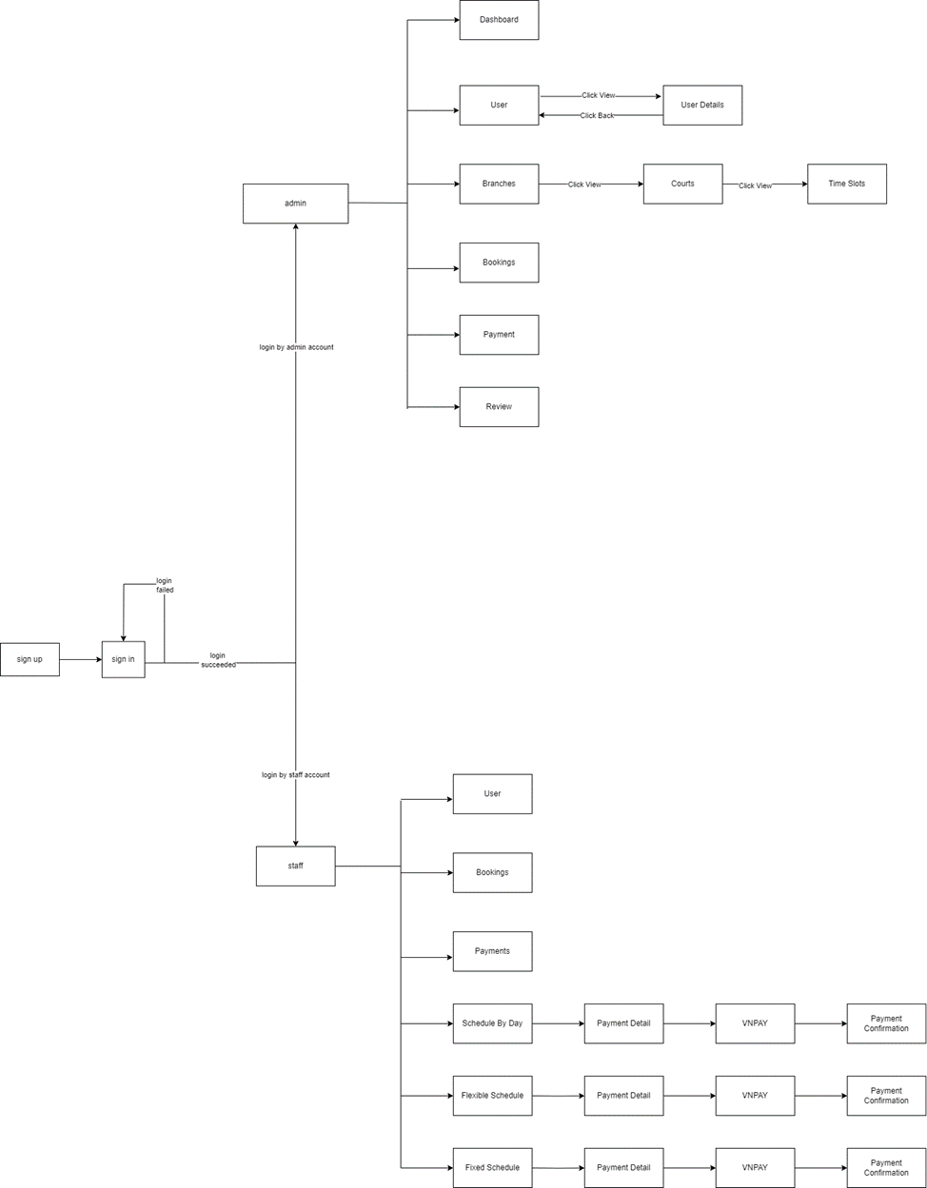

### 2.2 Business rules

|  |  |
| --- | --- |
| Id | Rule definition |
| BR-01 | Customers must provide a valid name, email address and password to register an account |
| BR-02 | Email must be in the correct format, email that has never registered an account before |
| BR-03 | Password must contain at least 6 characters including at least one upper case, one lower case, 1 special character and a number |
| BR-04 | the customer provides the account's email address to change the password. |
| If the email exists in the system, a confirmation link to change the password will be sent to the email |
| If email does not exist in the system, it will notify customers. |
| BR-05 | Account that has “Ban” status will be displayed by “Ban” information in User System |
| BR-06 | Customers must log in to their account to book the Court |
| BR-07 | Customers can book the yard according to 3 types of calendars: Booking by Day Booking Fixed Schedule Booking Flexible Schedule |
|
|
|
| BR-08 | For the booking by day type: Customers are allowed to book a minimum of 1 slot and a maximum of 3 slots, each slot 1 has a duration of 1 hour |
| BR-09 | For Fixed Schedule booking type: Customers are allowed to book up to 6 months, each week is allowed to book up to 7 days, each day is allowed to book 1 slot |
| BR-10 | For Flexible Schedule booking type: customers can book a maximum of 10 slots |
| BR-11 | If the customer cancels the booking, the customer will be fined 50% of the payment amount, the remaining 50% of the amount will be converted into Balance for the customer |
| BR-12 | Customers can only view the bookings of their own account. |
| BR-13 | For upcoming bookings, customers are allowed to View information or Cancel that booking. |
| BR-14 | For Cancel bookings, customers are only allowed to View information, not cancel. |
| BR-15 | For Overdue bookings, customers are not allowed to view information or Cancel |
| BR-16 | Customers must pay the field booking fee immediately after successfully booking the field |
| BR-17 | Court booking fees are calculated by the hour and may vary depending on time, day of the week, type of booking |
| BR-18 | The system accepts payment methods including VNpay and Balance |
| BR-19 | Customers can only refund 50% of the amount after canceling the booking |
| BR-20 | Customers are not evaluated or responded to if they have not logged in to their account or have no schedule yet |
| BR-21 | Customers can contact directly or request support through "Messenger" app |
| BR-22 | Only admins can create, edit, or delete user and employee accounts |
| BR-23 | Only admin has the right to lock or unlock user accounts when necessary |
| BR-24 | Only admin can add, correct or delete information about badminton courts |
| BR-25 | Only admin can change slots |
| BR-26 | Only admins can create and view reports on yard booking activities, revenue and feedback from users |
| BR-27 | Only admins can create and send notifications to all users about events, promotions or regulatory changes |
| BR-28 | Staffs can view yard schedules and schedule them according to customer requirements |
| BR-29 | Staffs and admin can update the court status |

### 2.3 Requirements

* 1. Guest
     1. Sign up: register as customers, creating an account for booking and other services.
     2. Locate courts: have the ability to search for available courts at various branches
     3. View court details: can view detailed information about each court, including name, facilities, and locations.
     4. View feedback of branch: view feedback and reviews about branches.
  2. Customer
     1. Booking court:
* By-day: booking a court for a specific time.
* Fixed: reserve a court for a fixed time slot in the week or month.
* Flexible: booking a total number of slots (or time) and register for these slots at any time.
  + 1. Cancel booking: cancel a booking and receive a partial refund credited to the account balance
    2. View court info: can view detailed information about each court, including name, facilities, and locations.
    3. Send feedback to a branch: provide feedback to a branch (only if a booking has been made at that court before)
    4. View feedback of branch: view feedback and reviews about branches
    5. View booking history: view past booking history
    6. Buy slot times: purchase slot time for flexible bookings (branch)
    7. Change user detail: update the account details
    8. Logout: log out of the account.
  1. Admin
     1. Manage court branches:
        1. View branch: view details of each branch.
        2. Add branch: add new branches to the system.
        3. Search branch: search for specific branches.
        4. Delete branch: delete branches from the system.
        5. Update branch: update details of existing branches.
     2. Manage courts:
        1. View court: view details of each court.
        2. Add court: add new courts to branches.
        3. Search court: search for specific courts.
        4. Delete court: delete courts from the system.
        5. Update court: update details of existing courts.
     3. Manage booked slots:
        1. View booked slot: view details of booked slots.
        2. Update booked slot: update details of booked slots if necessary.
     4. View payments: view payment transactions and histories
     5. Manage accounts (customers, staff):
        1. Add staff: add new staff accounts.
        2. Delete staff: delete staff accounts.
        3. Ban user: ban users from the system.
     6. View dashboard: Admin can see analytical charts, court information, revenue, and predictions about booking volume and revenue
     7. Generate reports: generate reports for analysis and record-keeping.
     8. Logout: Admin can log out of their account.
     9. Update working time: update the timeframe all slots can be active
  2. Staff
     1. View Customer Information: access customer
     2. Update Court Status: update the status of courts (e.g., available, maintenance).
     3. View branch: view details of their assigned
     4. View booking list: see a list of all bookings
     5. View customer booking history: view the booking history of a customer (?)
     6. Book for customer: make bookings on behalf of customers.

# II. Design

## Database design

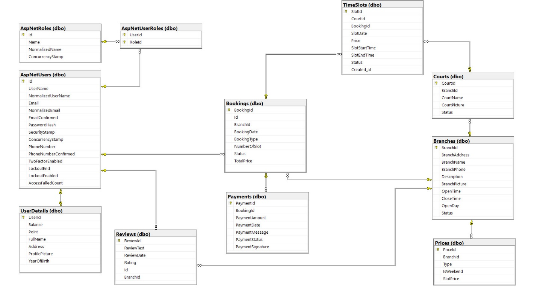

## Class diagram(s)

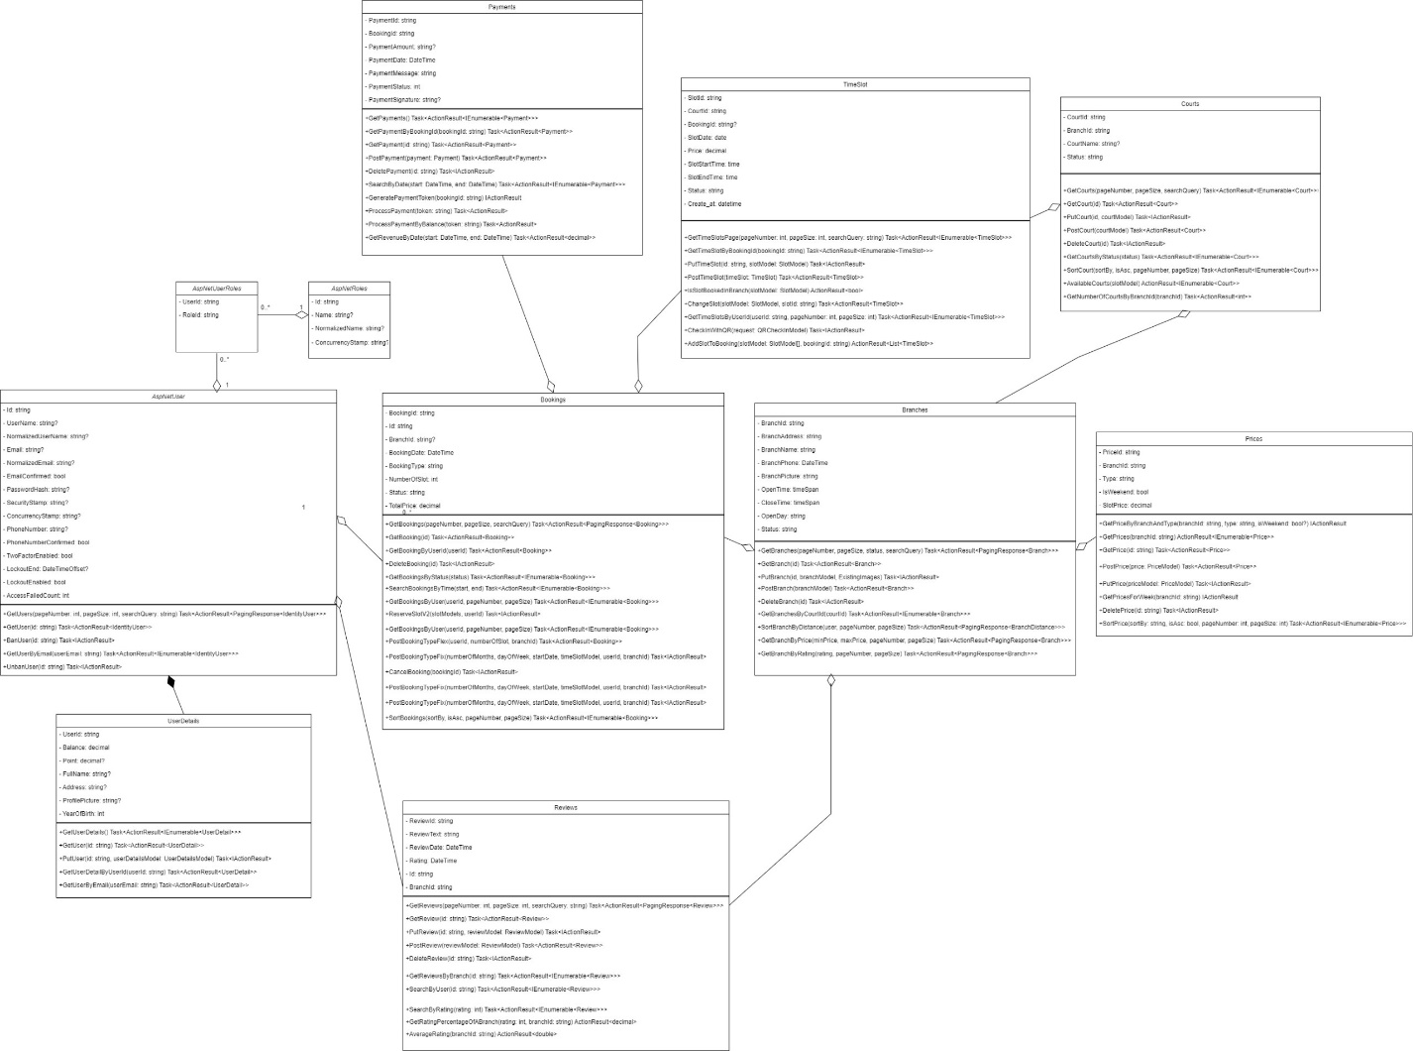

## Sequence diagram(s)

Sequence diagram describes how the web API system handles when a user sends a create account request.

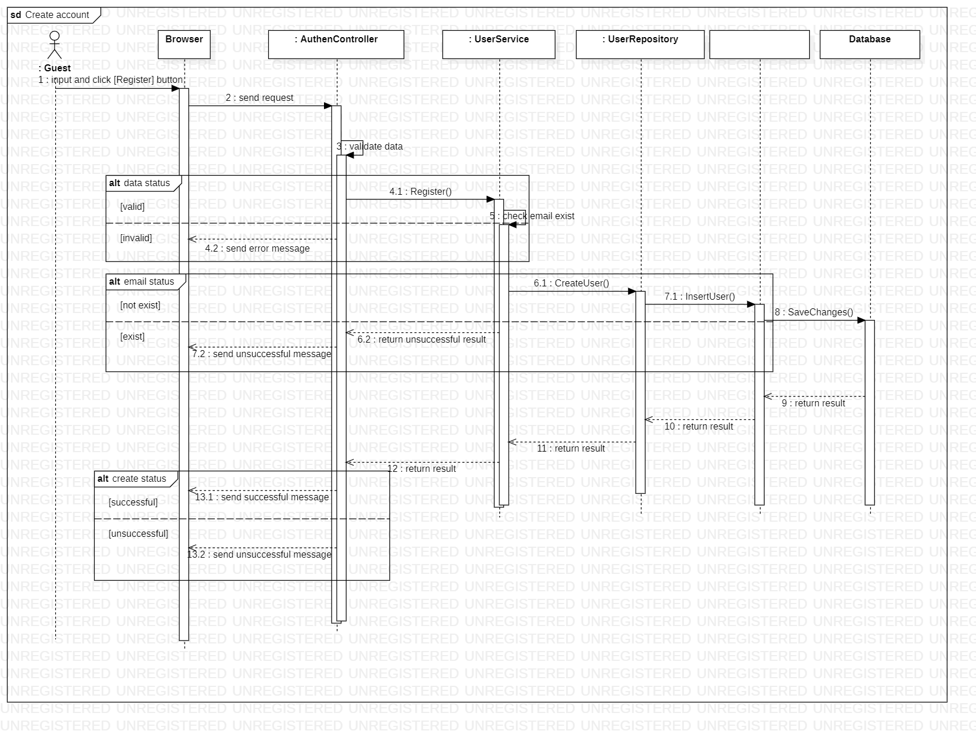

Sequence diagram describes how the web API system handles when a user sends a login request.

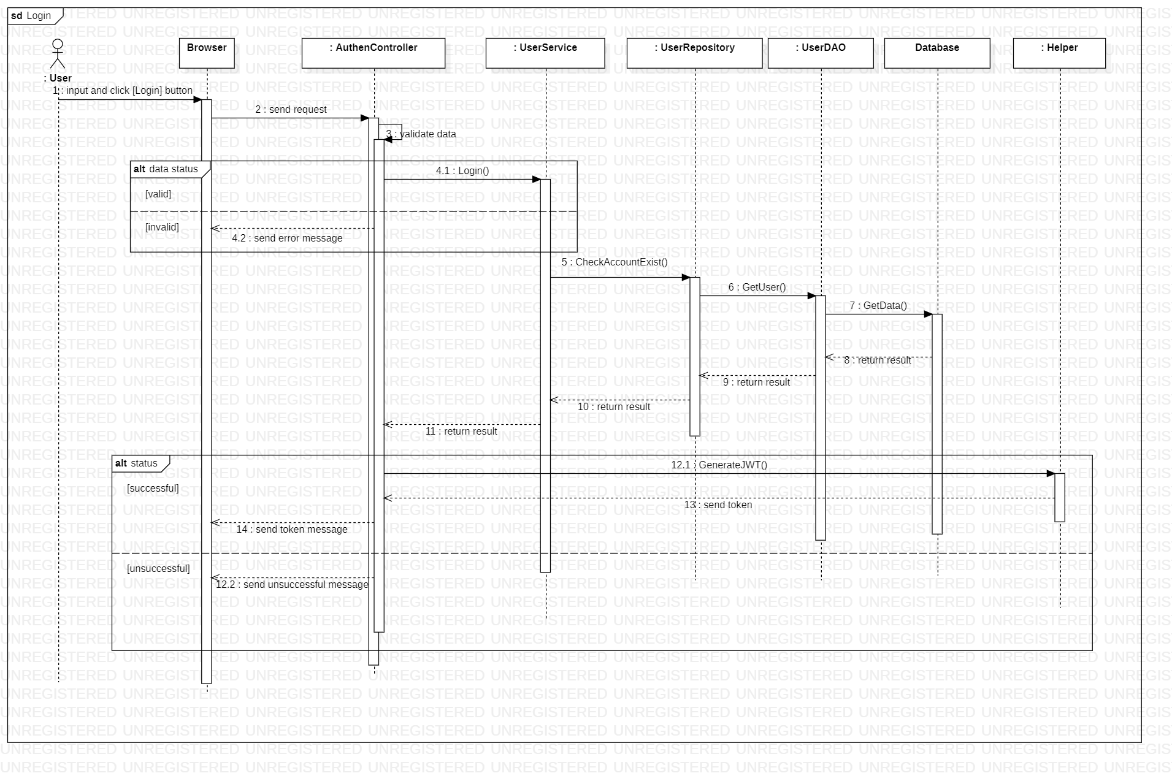

Sequence diagram describes how the web API system handles when a user sends a login with Google request.

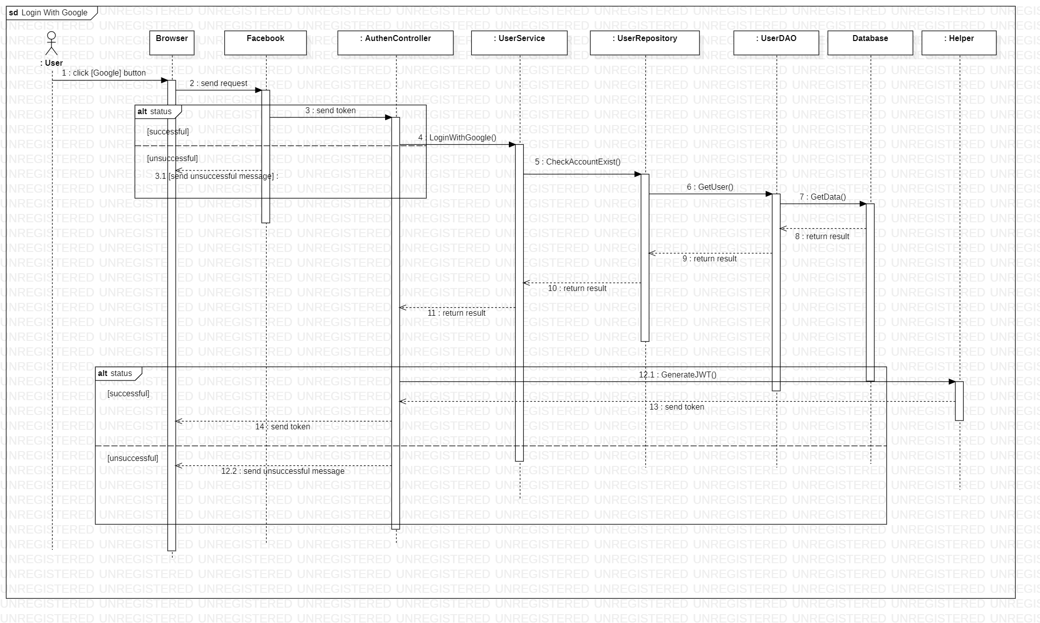

Sequence diagram describes how the web API system handles when a user sends a login with Facebook request.

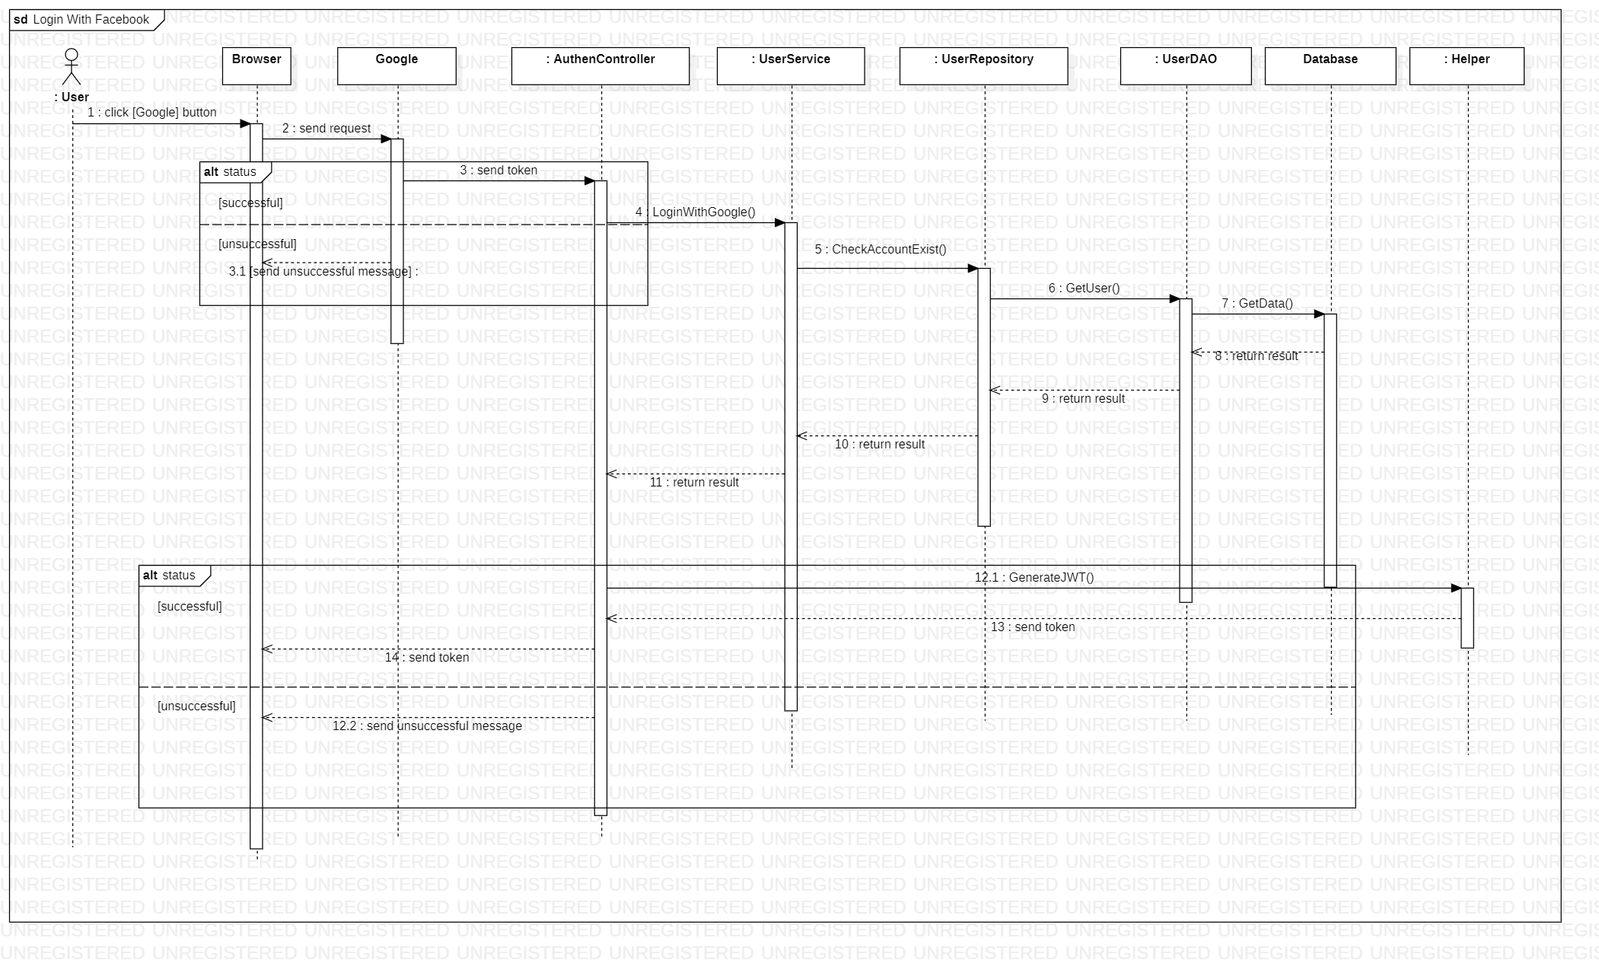

Sequence diagram describes how the web API system handles when an admin sends a delete branch request.

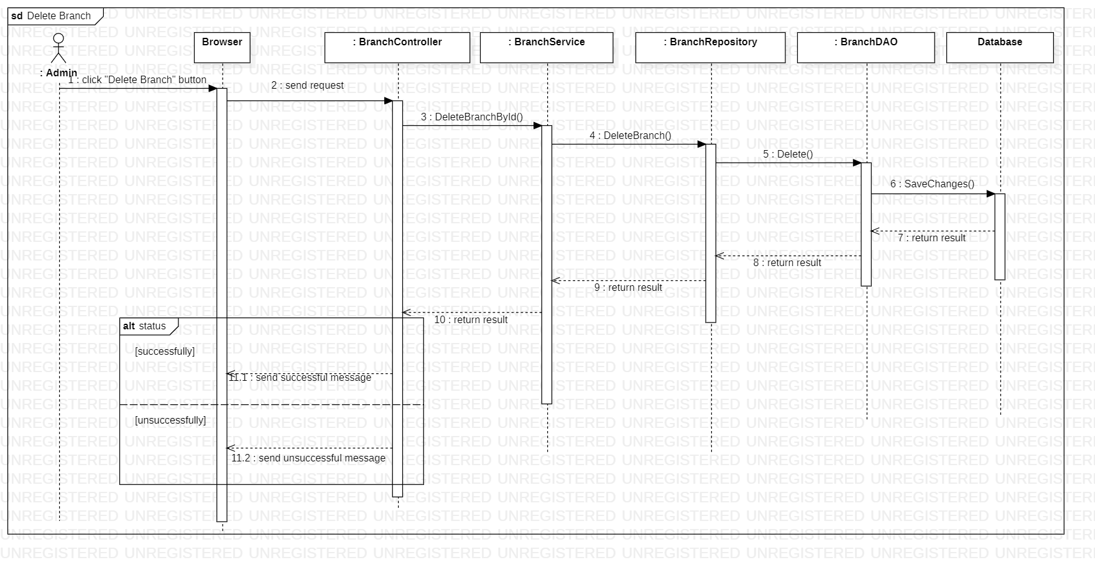

Sequence diagram describes how the web API system handles when an admin sends a delete court request.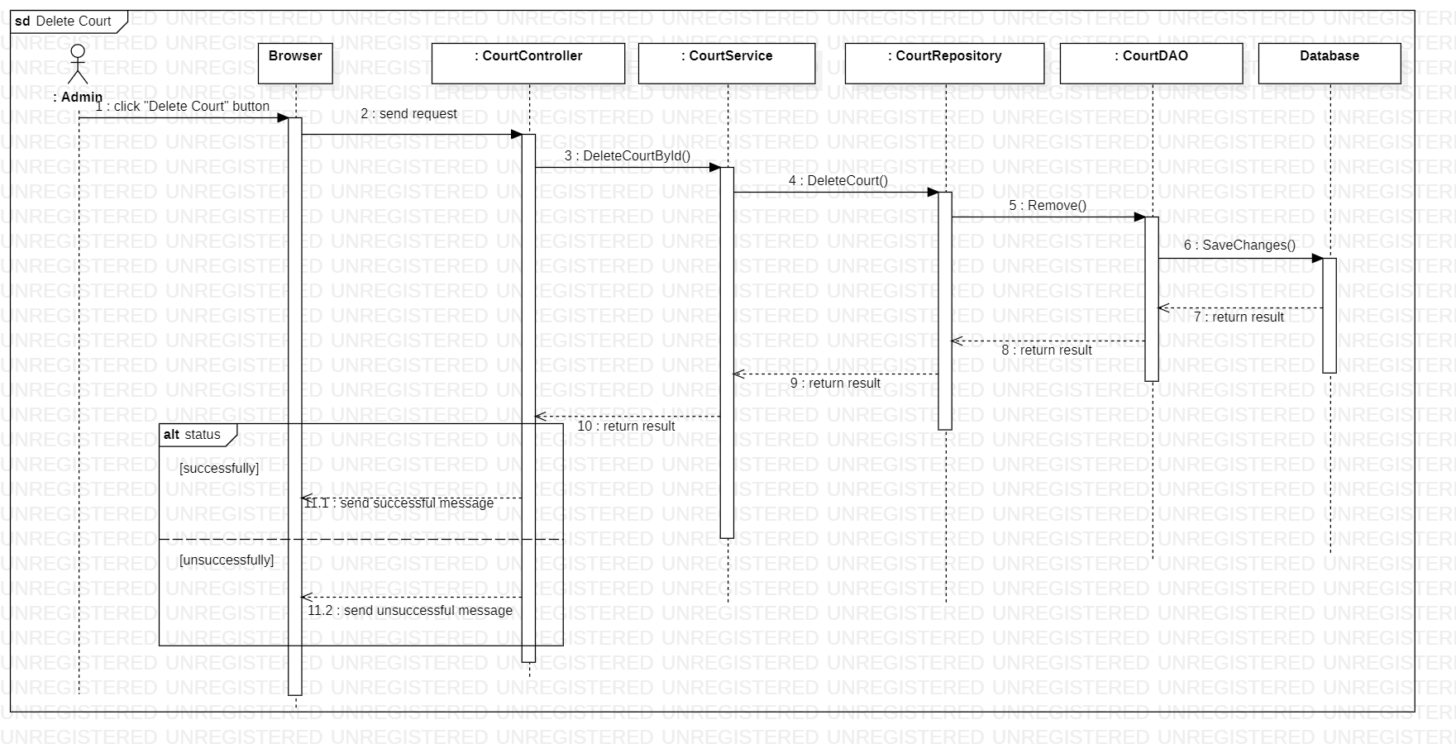

Sequence diagram describes how the web API system handles when an admin sends a delete review request.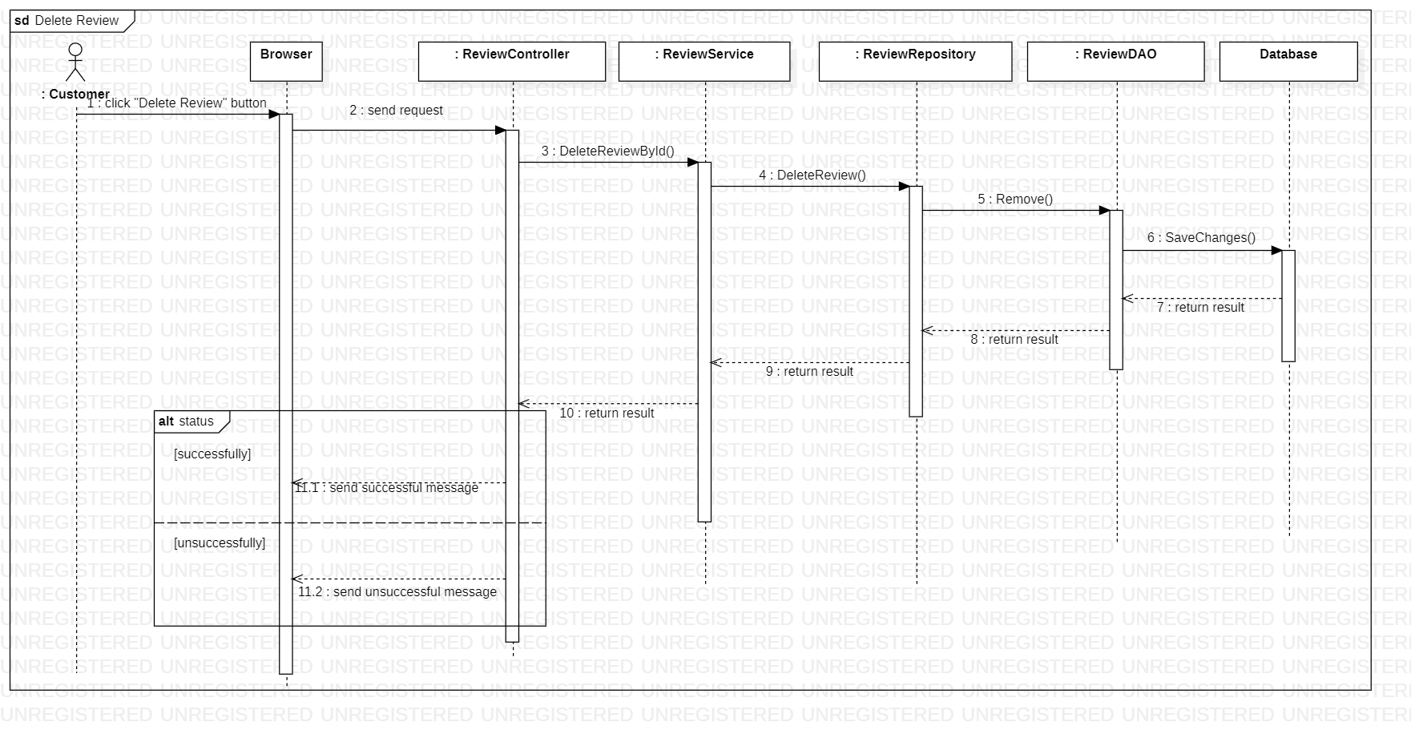

Sequence diagram describes how the web API system handles when a user sends a payment request.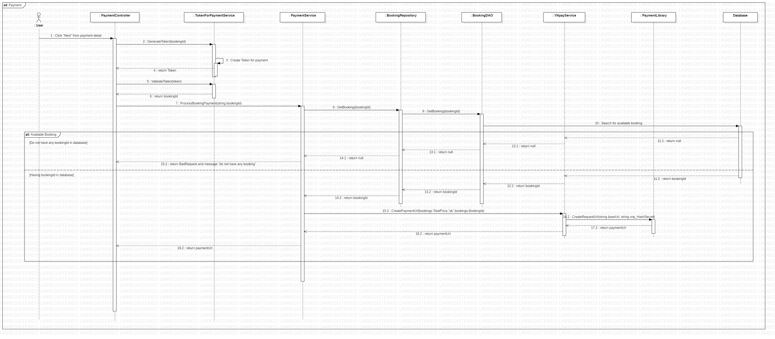

Sequence diagram describes how the web API system handles when a user sends a payment request.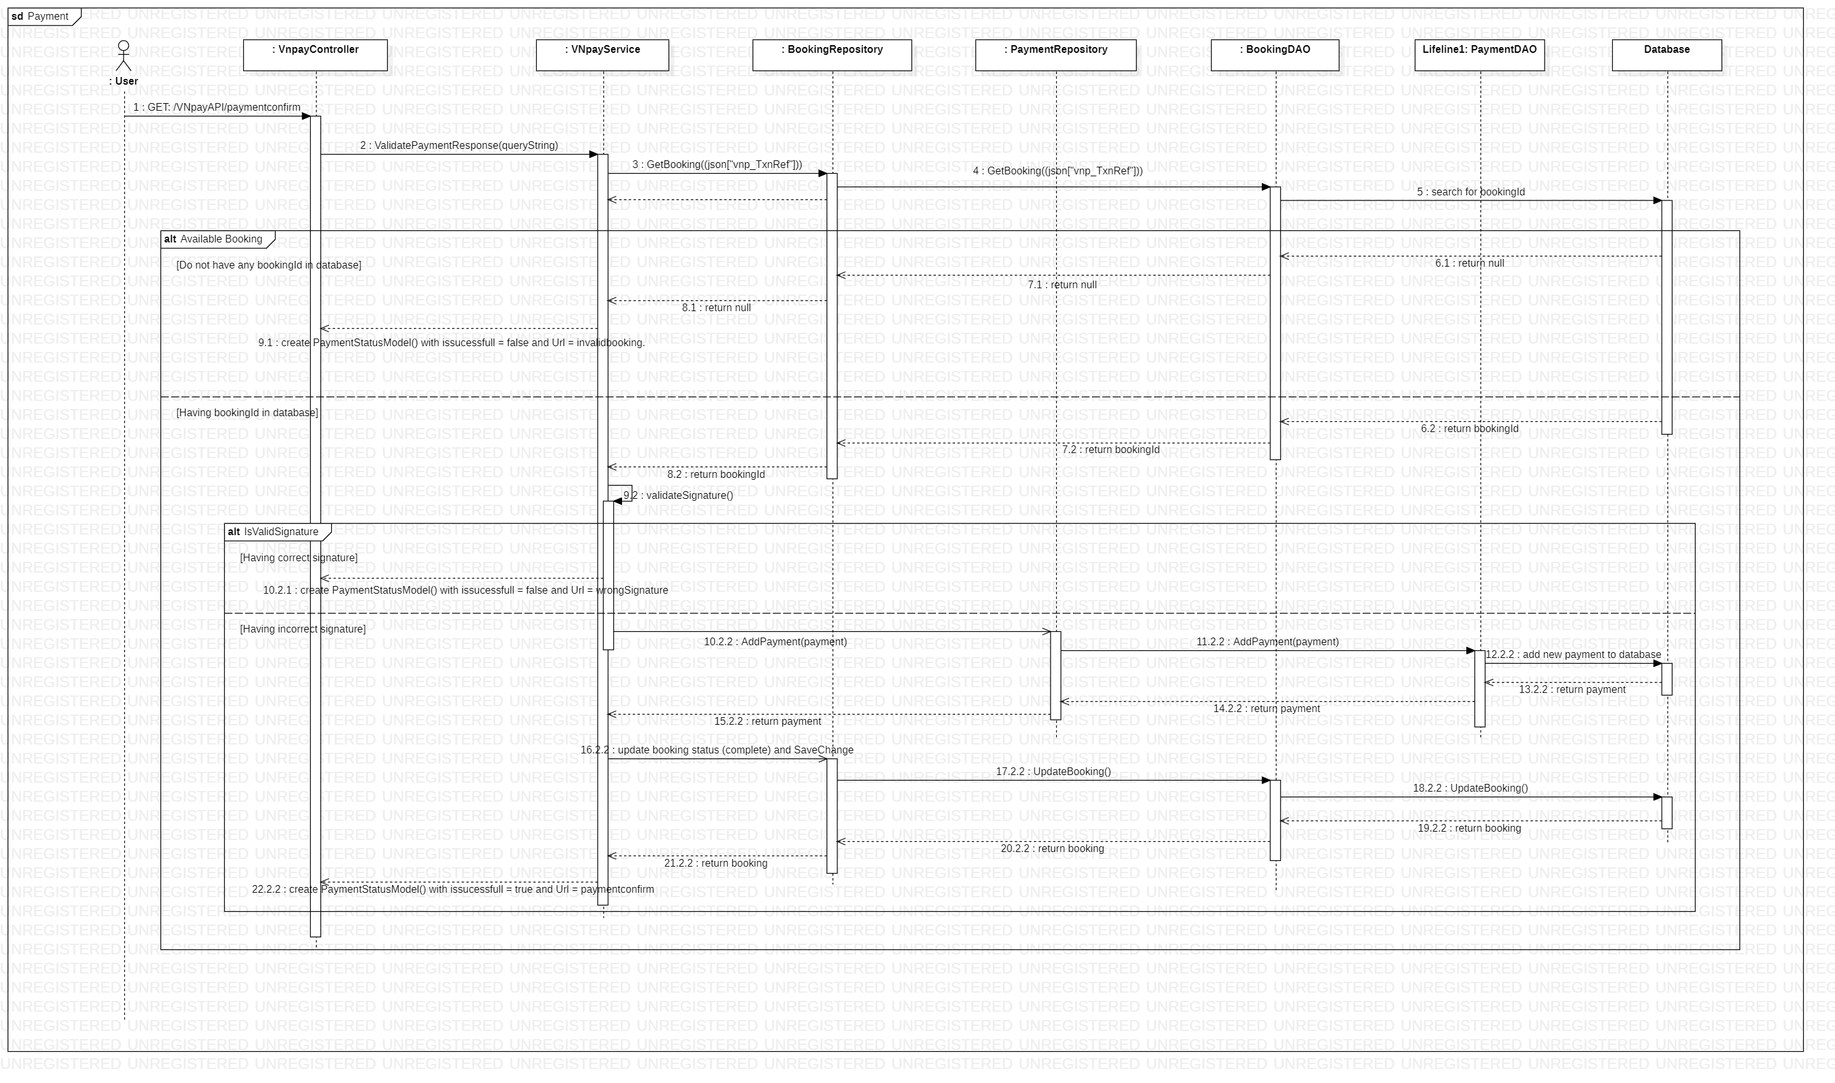

Sequence diagram describes how the web API system handles when a user sends a search branch request.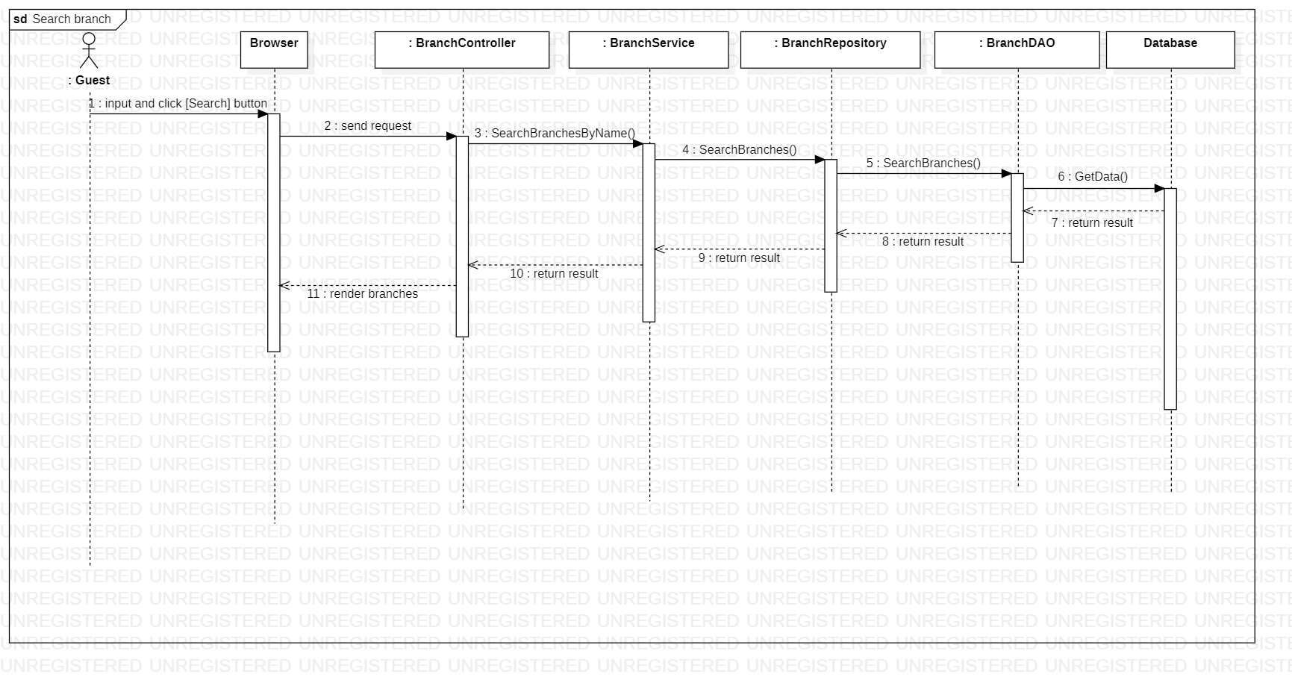

Sequence diagram describes how the web API system handles when a user sends a sort branch request.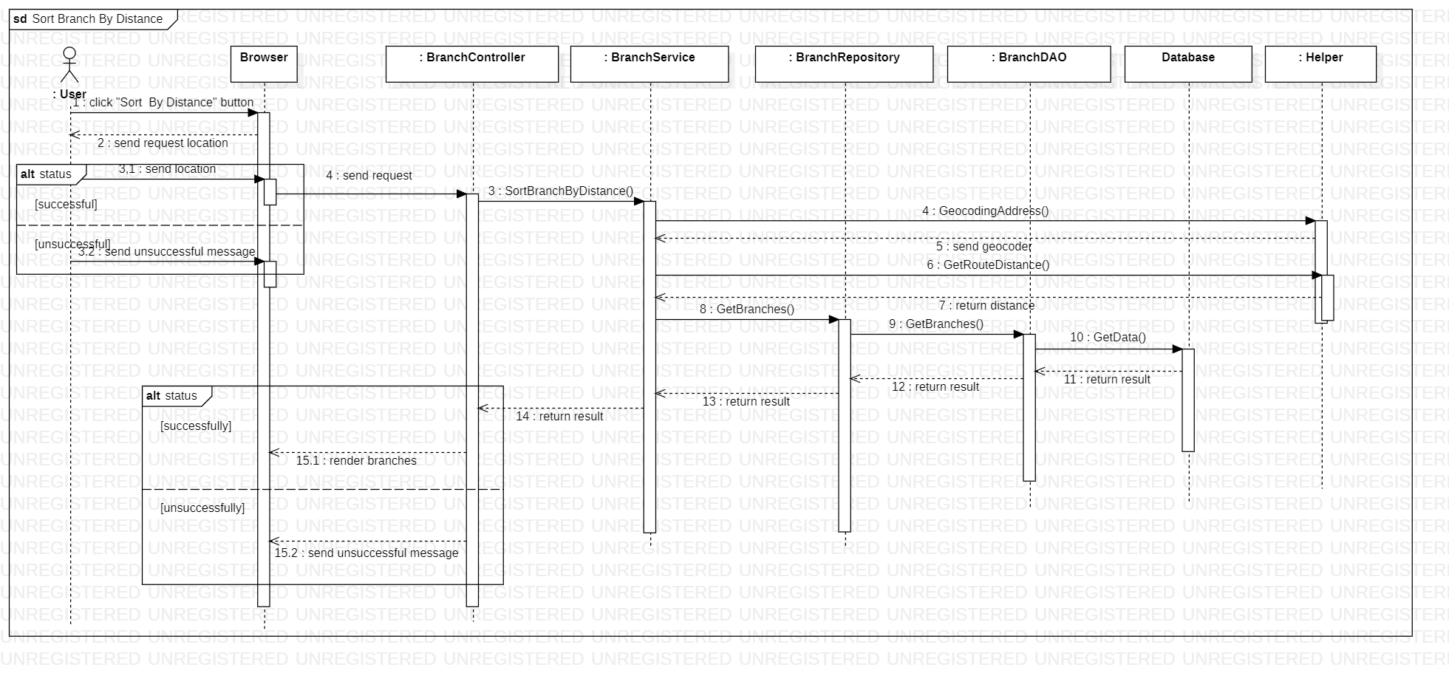

Sequence diagram describes how the web API system handles when a user sends a unban account request.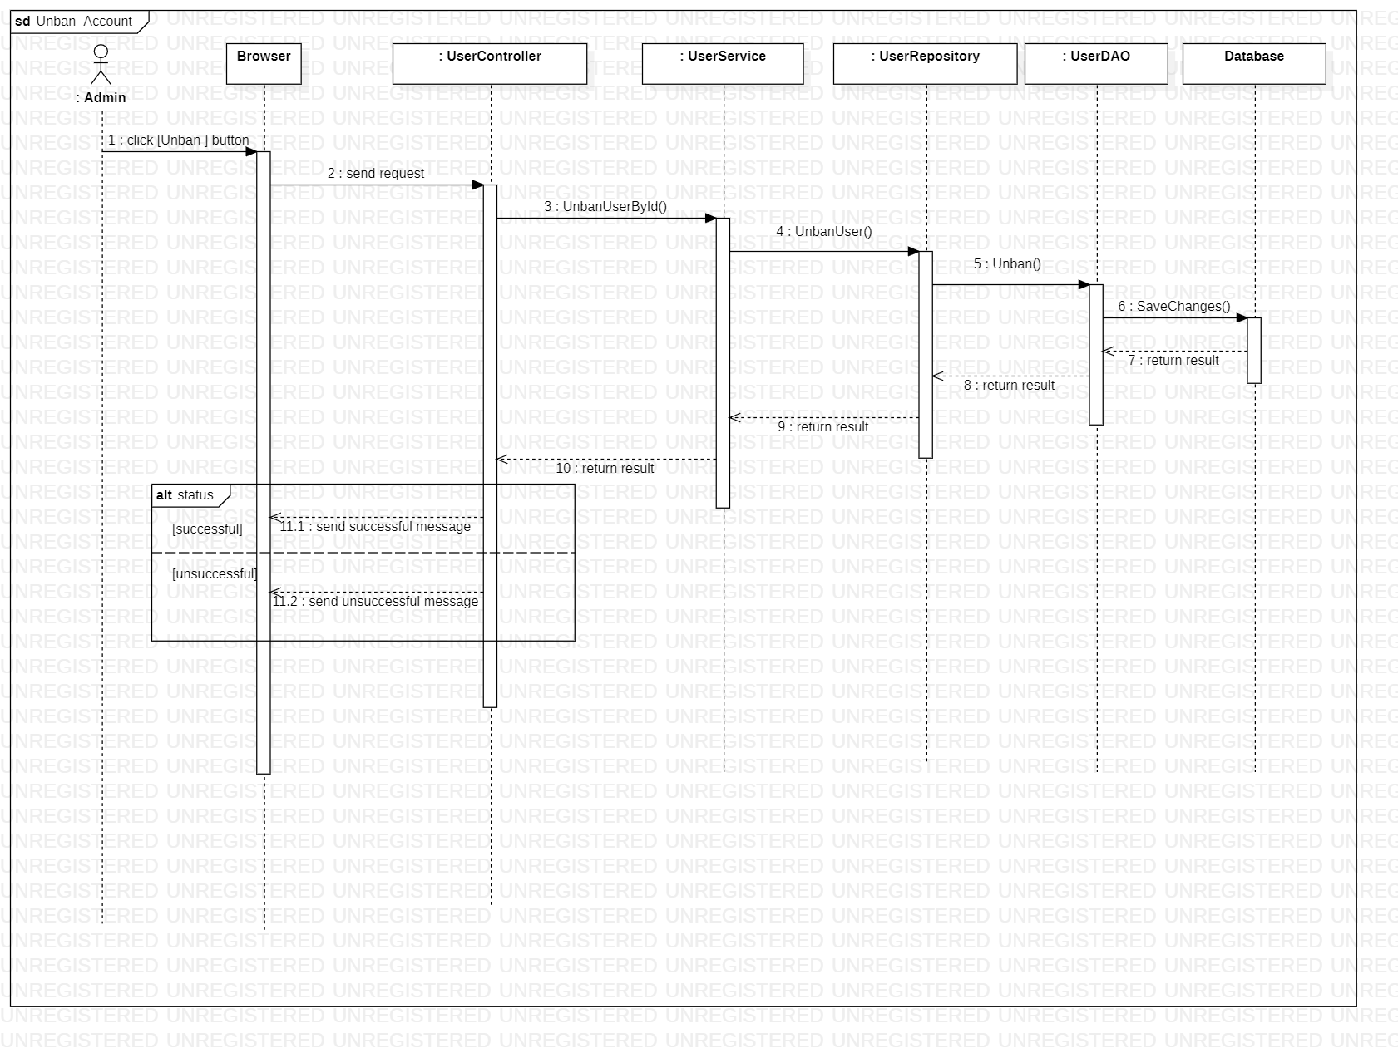

Sequence diagram describes how the web API system handles when a user sends a update branch request.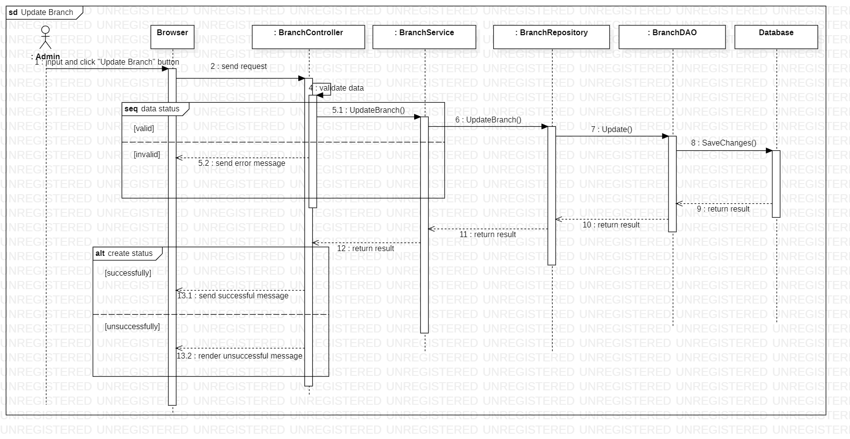

Sequence diagram describes how the web API system handles when a user sends a update court request.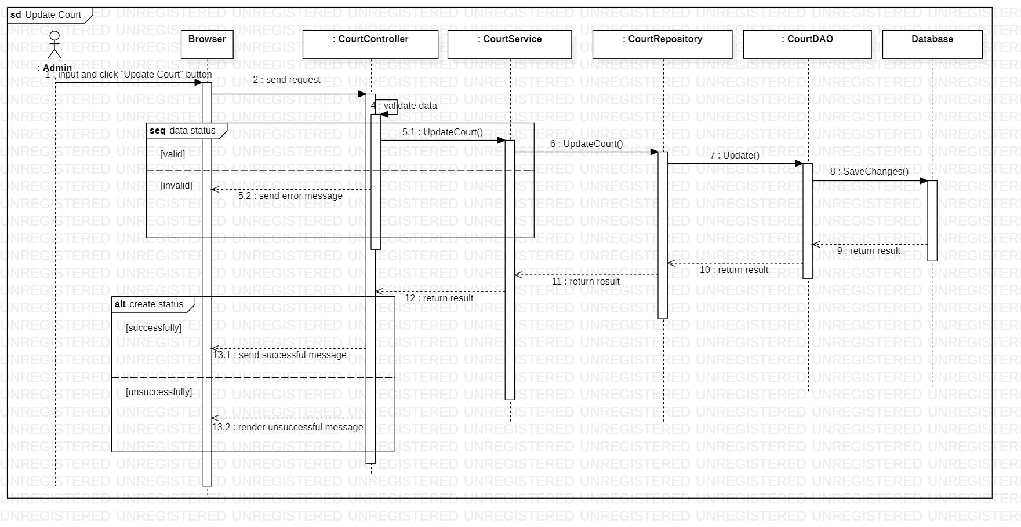

Sequence diagram describes how the web API system handles when a user sends a update profile request.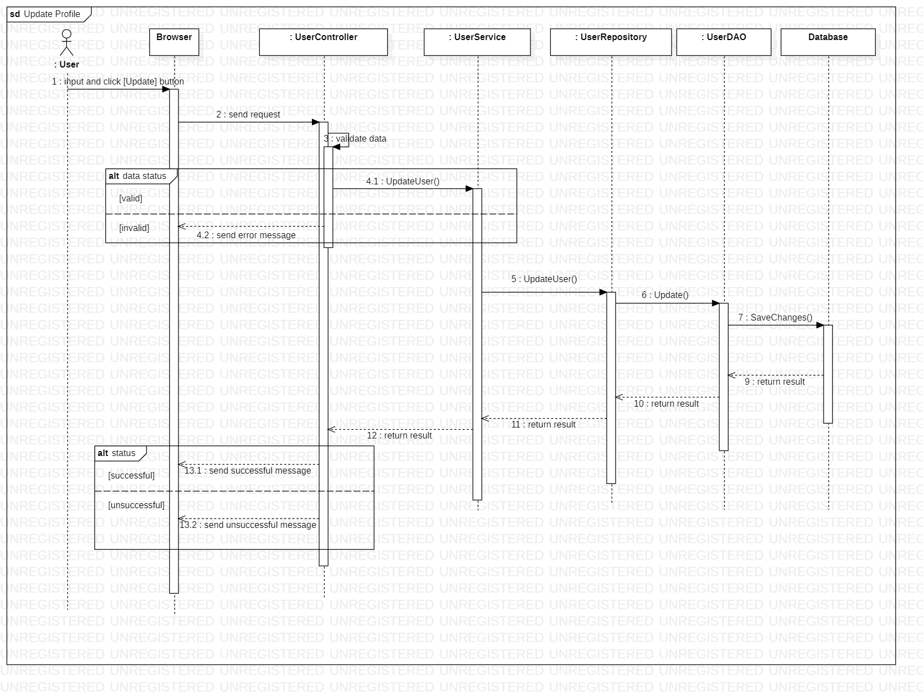

Sequence diagram describes how the web API system handles when a user sends a update review request.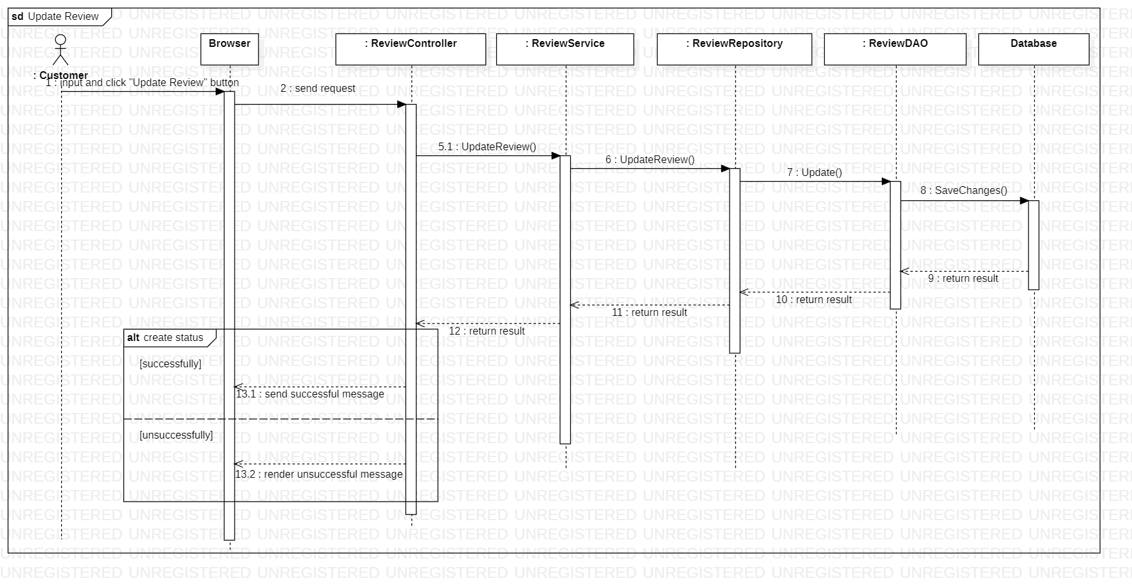

Sequence diagram describes how the web API system handles when a user sends a view branch request.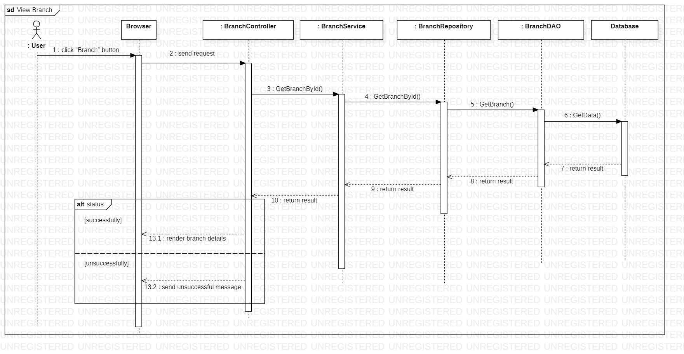

Sequence diagram describes how the web API system handles when a user sends a view court request.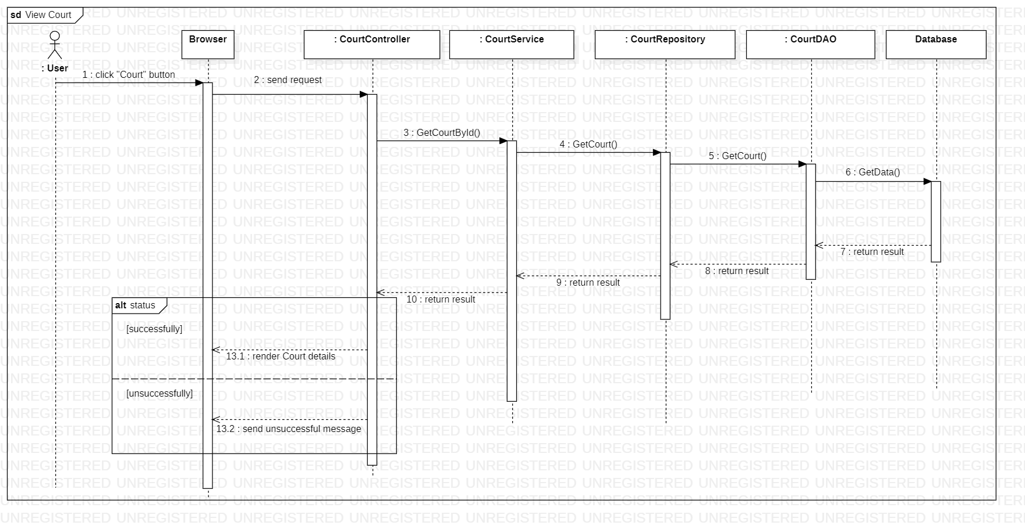

Sequence diagram describes how the web API system handles when a user sends a view profile request.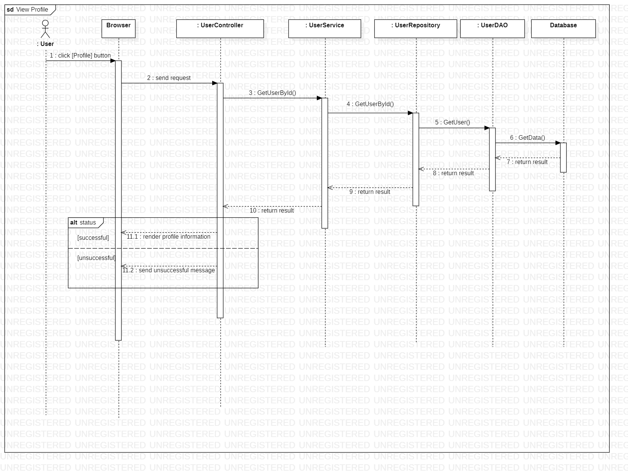

Sequence diagram describes how the web API system handles when a user sends a view review request.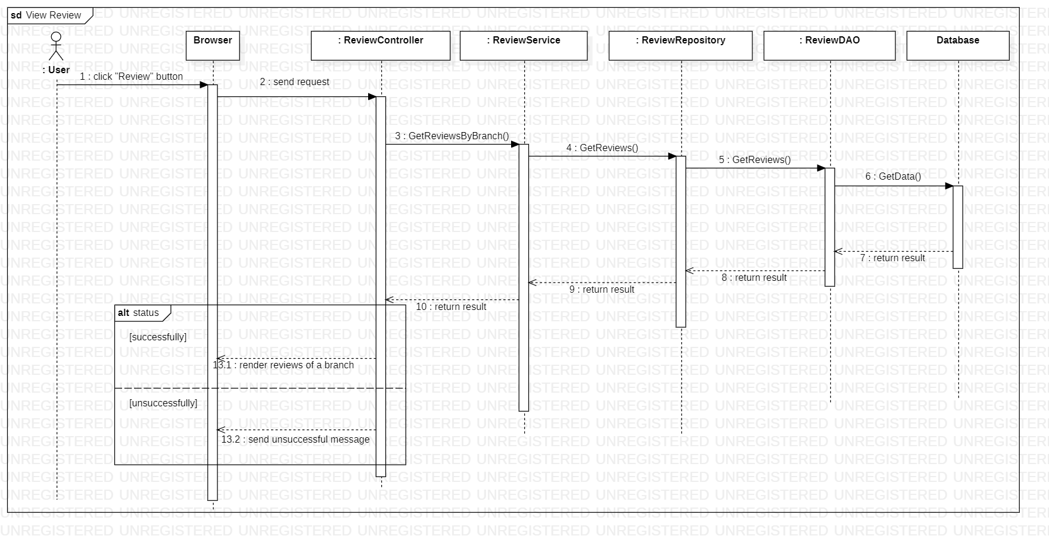

Sequence diagram describes how the web API system handles when a user sends a add branch request.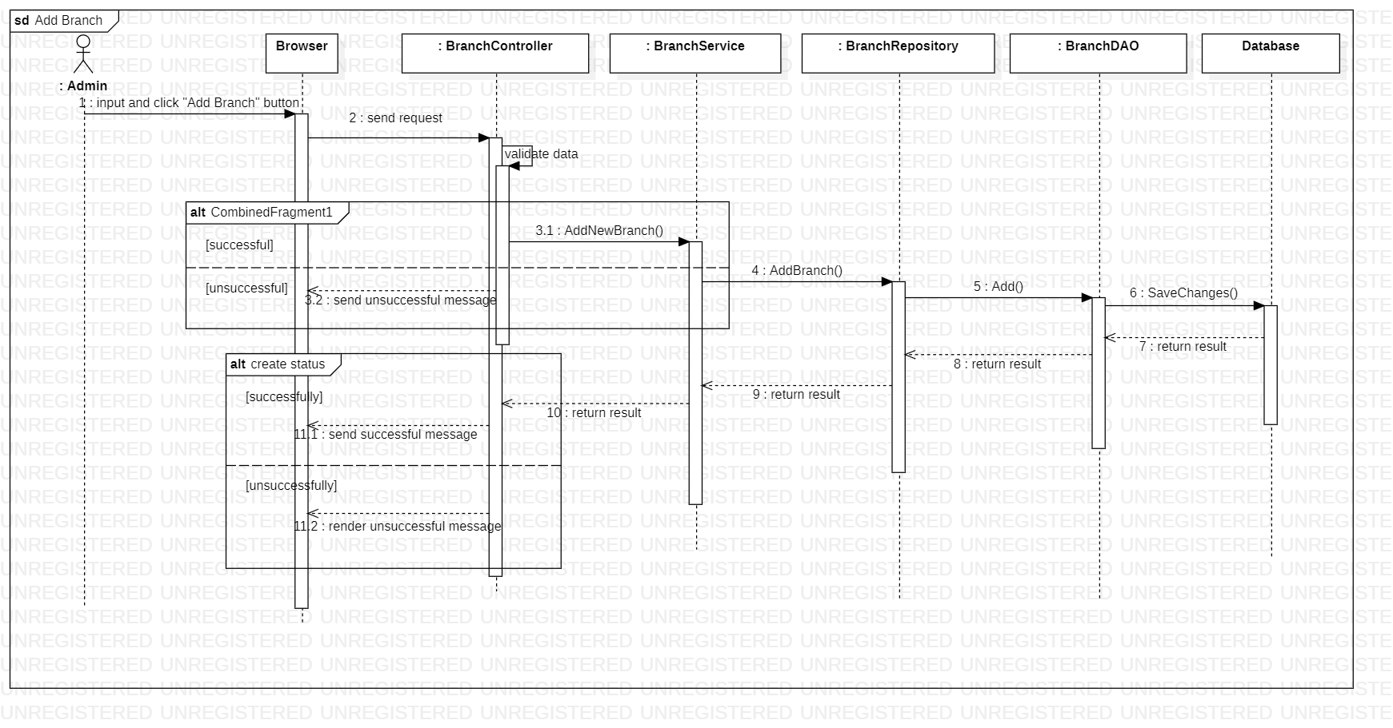

Sequence diagram describes how the web API system handles when a user sends a add court request.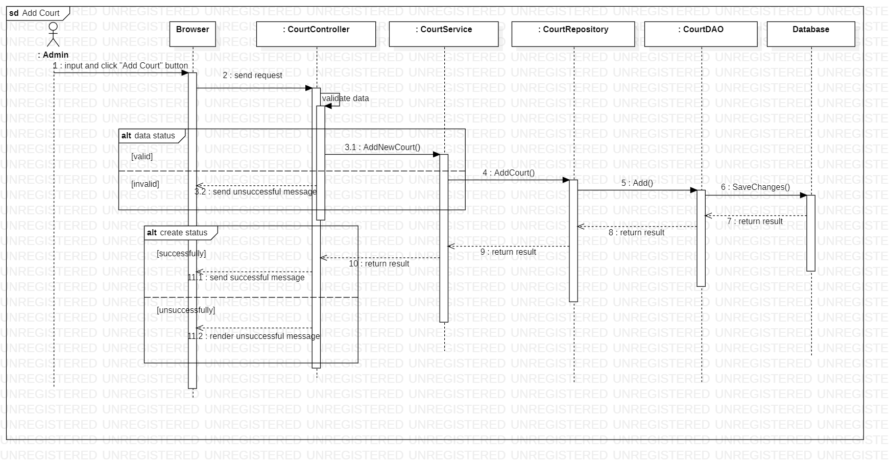

Sequence diagram describes how the web API system handles when a user sends a add review request.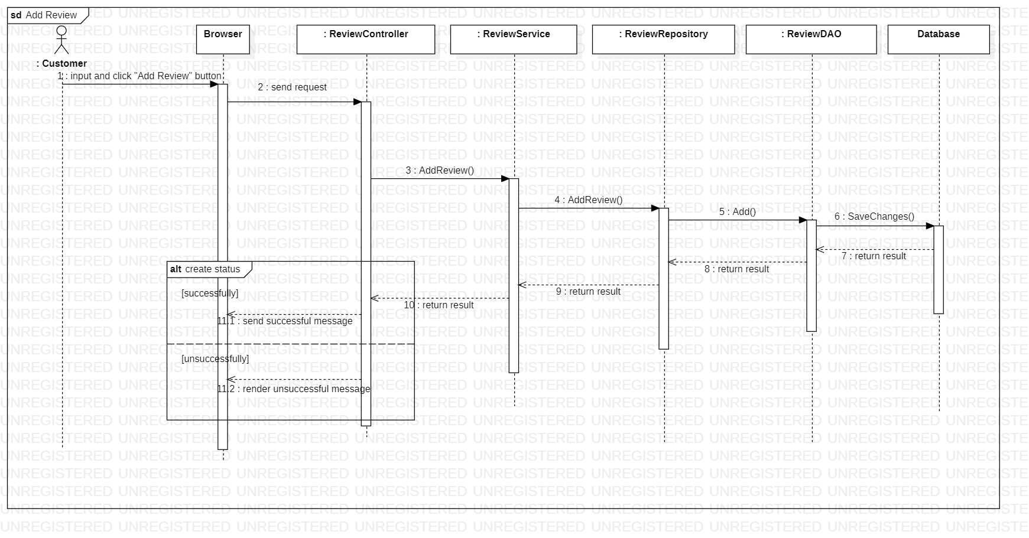

Sequence diagram describes how the web API system handles when a user sends a ban account request.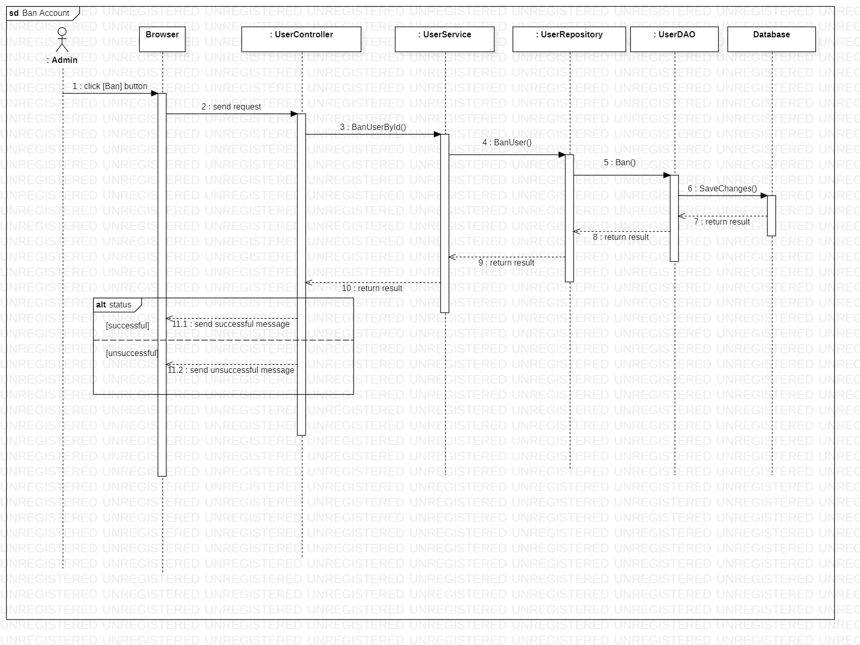 Sequence diagram describes how the web API system handles when a user sends a booking a court request.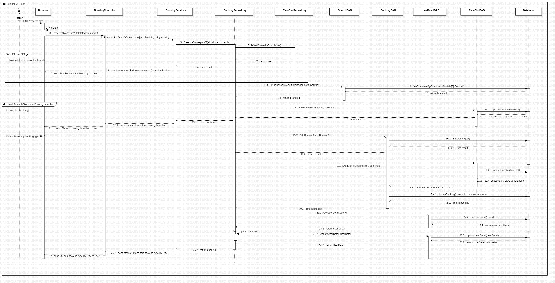

Sequence diagram describes how the web API system handles when a user sends a create a user (admin) request.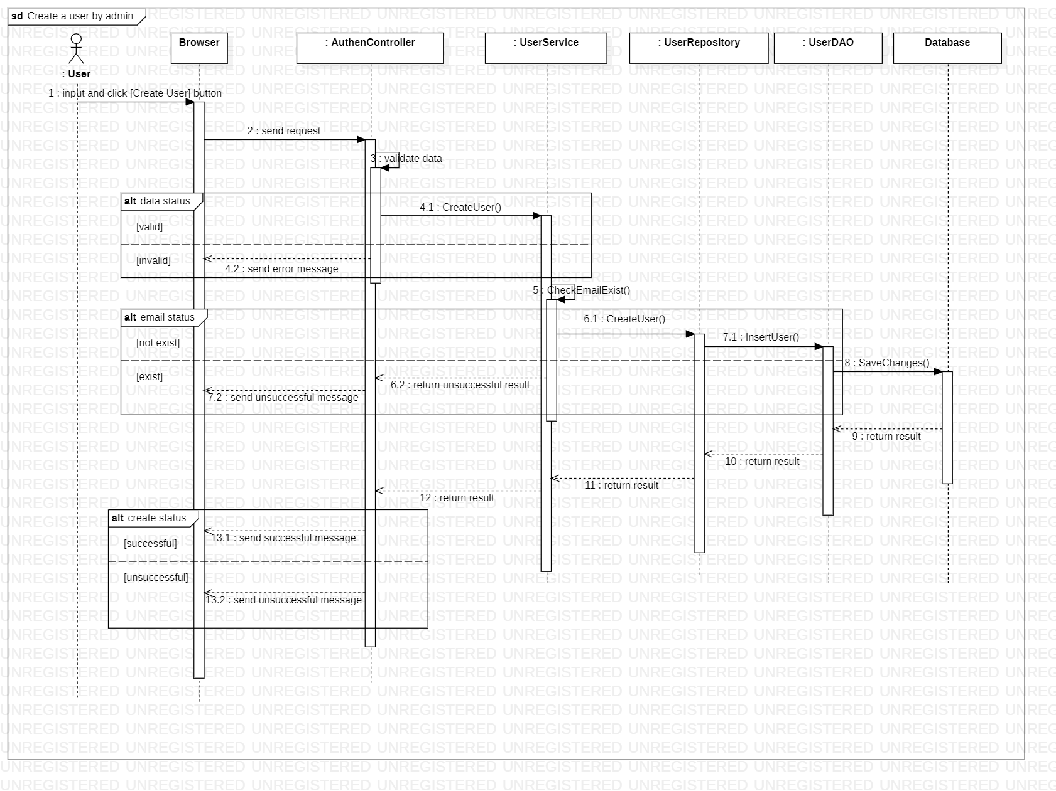

Sequence diagram describes how the web API system handles when a user sends a delete account request.